**Logo:**

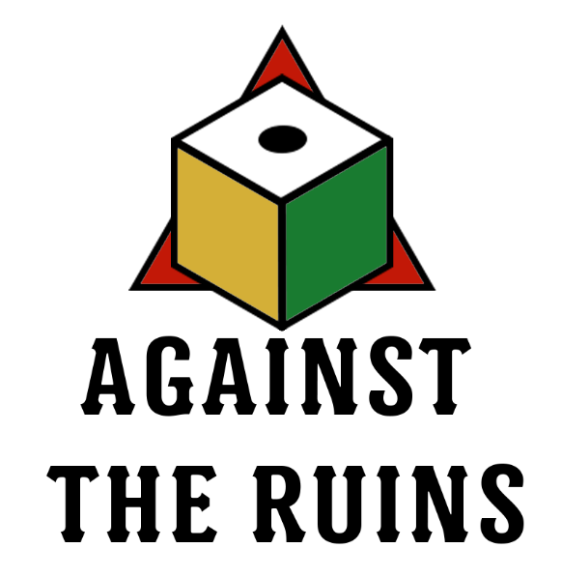

**Game Title** – Against The Ruins

**Elevator Pitch**

Take on the role of one of four Archaeologists of the Expedition as they delve to a strange ruin previously unknown to mankind, or be one of the derelict Ancient Guardians brought to life by the wanton looting of your domain.

Play cards, use Abilities, expose Relics, and roll dice to earn Trinkets or prevent losing them. With a massive deck for both the Expedition and the Ancient, as well as multiple Abilities and Relics to choose from every game, each expedition allows for a varied playstyle where you have to constantly adapt and strategize.

Will the Expedition live to tell the tale of a bygone era, or will the Ancient prevent further destruction of the Crumbling Expanse?

**Target Audience**

The general expected audience of this game are players 12 years old and above who enjoys relatively competitive card games, as well as asymmetrical play styles. Players are expected to strategize with and against each other in order to stay for as long as possible within the game, fostering a sense of long-term strategic thinking and planning despite unfavorable situations.

**Player Interaction Pattern – Unilateral Competition**

*Against The Ruins* is a game played with 5 people, 4 players assuming Archaeologist roles and one player assuming control of the Crumbling Expanse, known as the Ancient.

**Design Pillar**

Resource with Multiple Resources – *Against The Ruins* sees a specific resource, in this case Trinkets, being both the Ancient’s HP as well as the “gold” of the game, forcing the Ancient to manage conserving Trinkets while at the same time being forced to spend it all the same. This is seen in a similar but different way with the Expedition’s Green Dice being both the dice with which they primarily roll, as well as their “life”: they lose all their Green Dice, they are eliminated from play.

Asymmetrical Card Game – *Against the Ruins* employs an unbalanced team format, with one overpowered player against four relatively weak player whose advantage is being able to strategize.

**Inspiration(s)**

Some of the major inspirations of *Against The Ruins* is *Clank!, Dungeons & Dragons,* and *Risk*.

*Clank!* is a competitive deckbuilding board game where 4 players attempt to steal treasure from a dragon, whose actions are controlled solely by the game’s mechanics. The major difference between *Clank!* and *Against The Ruins* is the shift from pure competition to both cooperative and competitive play, as well as a move away from the deckbuilding nature of *Clank!.*

*Dungeons & Dragons*, or *D&D* for short, is a tabletop roleplaying game that utilizes dice to do what are called Ability Checks, specifically Contested Ability Checks, to see whether a player character succeeds in whatever they do that may involve failing. This mechanic is similarly seen in *Risk*, a competitive game of world domination where dice are rolled to represent one’s unit soldiers. This specific mechanic is taken by *Against The Ruins* and amplified: players have to roll a lot of dice to determine success or failure.

**Game Loops**

**IN PHASE**

CARD DRAW/DISCARD

* Players must draw or discard cards until they hold exactly 5 cards in their hand. Relic and Ability Cards do not count towards this hand limit.
* If a deck becomes empty during play, all discarded cards (excluding Banished Cards) are reshuffled and added back to the deck.

REVEAL INFLUENCE

* The Ancient must show any Influence Cards they draw, placing one on the Influence Discard, resolving its effects, and repeating if necessary.

ACTIVATE RELICS

* The Ancient may Activate Relics during the Ready Phase. Relic Effects only resolve during the Rally Phase unless it affects dice and its values.
* An Activated Relic is Exposed at the end of the round.
* Every 2nd round after the Entry Phase, an Unexposed Relic must be Activated. If not, an Unexposed Relic chosen by the Archaeologists is immediately Exposed.
* Activating a Relic is not considered as placing a card.

INITIATE HEIST

* Any Archaeologist may Initiate a Heist to claim an Exposed Relic for the Expedition.
* The Initiator may only place one card during a Heist. The Alert mechanic is ignored for the Initiator.
* On a Successful Roll:
  + The Relic is Claimed. The Relic Card and Token is given to the Initiator.
  + The Initiator gains 1 White Die, which is immediately rolled. On a 1 or 2, nothing happens. On any other value, Alert increases by 1 immediately.
* On a Failed Roll:
  + The Initiator gains 1 Danger.

PLACE CARDS

* All players must place at least one card on a Card Slot. Card effects are resolved after the Ready Phase.
* The Ancient can place up to 4 cards (3 if a Relic is Activated), while an Archaeologist can place up to 2 cards (1 for a Heist Initiator).
* If the Ancient cannot or refuses to place a card, they lose 1 Trinket to each playing Archaeologist at the Recoup Phase.
* If an Archaeologist cannot or refuses to place a card, they gain 1 Danger at the Recoup Phase.
* When placing a card, players are also required to place the corresponding Trinket Cost on the top of the card, as well as any additive effects. Subtractive effects, such as dice or card disabling, only occurs during the Rally Phase.
* If a card effect necessitates the use of a token, these tokens are placed on top of the said card. If a card effect affects all Archaeologists, dice or tokens corresponding to this effect are placed on the empty space in front of the Danger Meter.
* An Archaeologist’s turn is finalized once they place all active Dice ahead of the Danger Meter.
* The Ancient’s turn is only finalized once everyone else is ready to proceed.

**OUT OF PHASE**

PLAY INSTANT CARDS

* Instant Cards may be played any time, or on specific phases. These still cost Trinkets, but must be placed ahead of the Danger Meter to be played.
* Using Instant Cards are not considered as placing a card.

USE ABILITY

* Archaeologists may use their abilities during specific phases to improve their odds. The Ability must be resolved before play can proceed. When using an Ability with a Cooldown, Cooldown Tokens are placed on top of the Ability Card upon its use.

STRATEGIZE

* Archaeologists are free to converse and plan with each other, and may even look at cards of other Archaeologists. However, they cannot:
  + place cards for any other Archaeologist other than themselves;
  + trade trinkets and cards with other Archaeologists; or
  + roll for other Archaeologists unless a card states otherwise.